SWE30010

HRM PROPOSAL FOR GEMADEPT

Name: Nguyen Dinh Nhat Minh  
ID: 103802490  
Tutor: Thomas Hang

**Evidence**

# Work Burndown Chart

A burndown chart to keep track of the days it should take in order for the sprint to be completed. It is important to note that this chart represent the total effort for all the sprint product in sprint one and not particularly any sprint product.

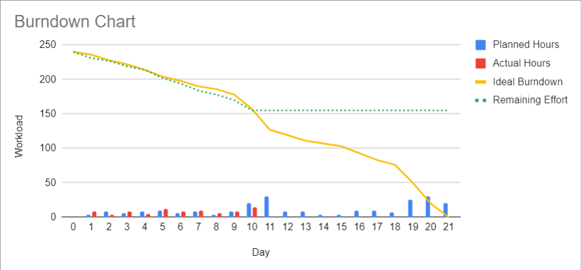

*Figure 1.1: Sprint 1 burndown chart*

*Figure 1.2: Sprint 1 burndown table*

# Work Breakdown Structure

We created a WBS chart to estimate the effort it would take to develop the base website for our project. Other sprint products are merely features or design for our website, hence we put our focus on analyzing this particular product.

*Figure 2.1: WBS Chart with Time Estimation for each task*

1. **Website building – Front end and Back end**

Per inquiry with our developer, he spent 40 hours (which amount to 4 hours per day) on the website’s backend and front end, he also recorded all of his work on Github for ease of review.

**Front end Github:**

*Figure 3.1, 3.2, 3.3: Front-end Github commits*

**Back end Github:**

*Figure 3.4, 3.5, 3.6: Back-end Github commits*

As can be seen, he was able to push a number of commits on the dates that is parallel to the 9 dates he was able to work on the project. There is a lack of 1 commit on both he front and the back end which equals to 1 date, but it is due to the fact that some of the packages that should have been a separate commit, were collectively pushed into 1 commit.

1. **Rationale and Analysis**

We devise a product backlog that defined 4 sprints for our project, each sprint would be as long as 21 days, and the total work hour it would take for each of the them is 240 hours (about 3 hours per day for 4 person). In our first project sprint, we have got four tasks to tackle, building the website is the main focus and will likely be the most lengthy.

As of the moment, our team had finished the first 10 days of the sprint, so we reached the halfway milestone of our project. According to our burn down table and chart, we should have worked on the entire project at least 83 hour at this point and looking at the work breakdown structure, building the website will take around 44.5 hours in total, and since we had defined the website as the utmost important product in our plan, we put a lot more effort in to finishing that product first.

Given the predicted 44.5 hours needed for it in total, we were able to work on this website for 40 hours, give or take. This is within the 10% error margin of our project, as we have not yet completed the additional testing duty. Thus, of the 85 hours that we really worked on the sprint, the website consumes almost half of our time, leaving us with 45 hours to concentrate on the other three products.

Completing the website we had envisioned seemed like a great accomplishment, especially considering the amount of time and work that goes into establishing a website or software. It resembles demolishing a massive wall. The foundation for future feature additions is established by the essential functionality of this website.

In order to get ready for the upcoming sprint, we took some time to evaluate our performance from the previous one and determine how we were able to achieve a narrow margin of error. We found a few key components that truly helped us accomplish our goal of finishing the website in the allocated amount of time:

* **Consulting with Professionals:** Although the term "professionals" can be a bit wide, we tried to interact with people who might offer insightful information on the intricacies of creating a website (such as YouTube teachers, peers who have done a lot of web development, etc.). We felt that by getting outside advice, we were able to increase the precision of our estimates and gain a deeper understanding of the work needed for each component.
* **Leveraging past experiences:** Since every member of our team had studied web development and was aware of its complexity, we were able to analyze past data to find trends and patterns in the amount of time it took to complete tasks. It proved to be quite beneficial for us in terms of project planning.
* **Prioritize Important Tasks:** We eat the frog and complete the most important functions of our website first (e.g., database, payroll, handling user’s data, etc.), this allow us to do the smaller tasks later and not be too overwhelmed with the amount of work ahead, effectively make our processes more efficient.
* **Regular Meeting:** We held frequent refinement sessions prior to sprint planning because we believed in checking in with one another. This allowed us to review and reevaluate our initial estimations and gain insight into the work progress of other team members. By means of cooperative deliberations and input from fellow team members, we can enhance our approximations, accommodate new insights or modifications in specifications, and ensure compliance with team capabilities..

We believed that accuracy achieved in our project's progress stems from a combination of planning, prioritization of critical tasks, and adaptability to changing circumstances. By leveraging these strengths and remaining agile in our approach, we are well-positioned for continued success in future sprints and beyond.